**Action Magic: Double Negation**

**Inputs**

1. Ask a Question- Text: Enter Any Array?
2. User-provided values are stored in a variable like "**text”.**
3. When selecting "Method" the value as"**SELECTABLE**" and Magic Operation is "**doubleNegation**".
4. For the output result, provide the "**Double negation Argument"** value as **{{text}}** and set the output variable value as (eg.output).

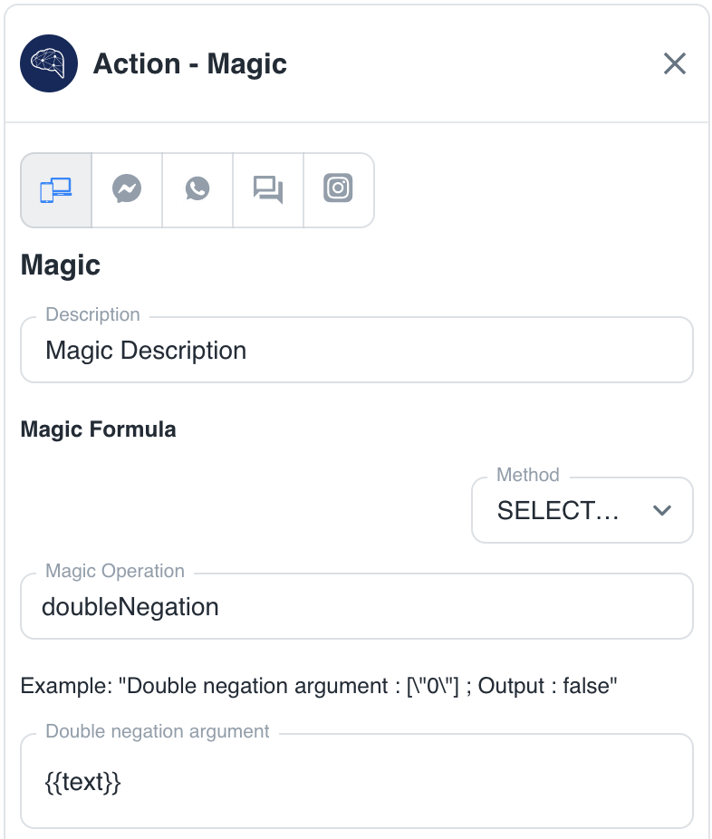

**Output:**

1. Enter the Array value = “true” and. The output is = true
2. Enter the Array value = “ ” and. The output is = false